Children’s Story Title: The Dead Sea is dead.

There is a big lake that borders the countries of Israel and Jordan in the Middle East called the Dead Sea.

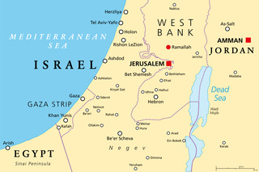

It's called the Dead Sea because it’s dead.  Nothing resides in it - there are no fish, seaweed, or plants of any kind in or around the water because there is too much salt in the water for any of these things to live.

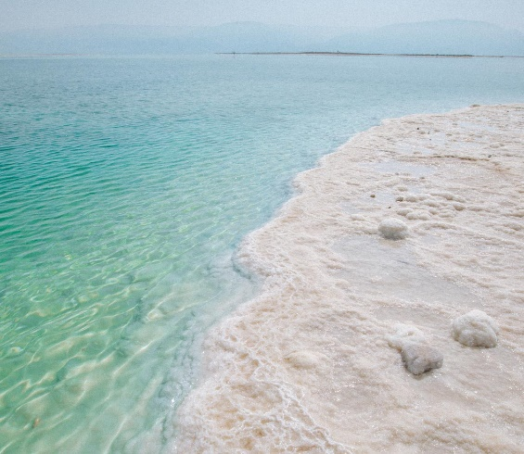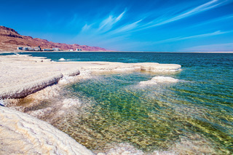What you'll see on the shores are clusters of white salt crystals.

The salt content in the water is so high that if you were to go swimming in it, you wouldn’t need any floating devices since the salt will hold you up.  You would float like a cork floats in the water.

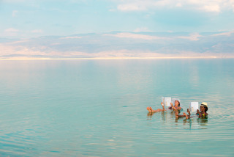

There is so much salt that if you don’t dry yourself with a towel there would be a white film of salt on your body.

What makes the Dead Sea so salty? The Jordan River feeds the Dead Sea, but the Dead Sea is situated at the lowest elevation point on earth.  It is 1,312 feet below sea level, so the water can’t flow anywhere else once it gets there.

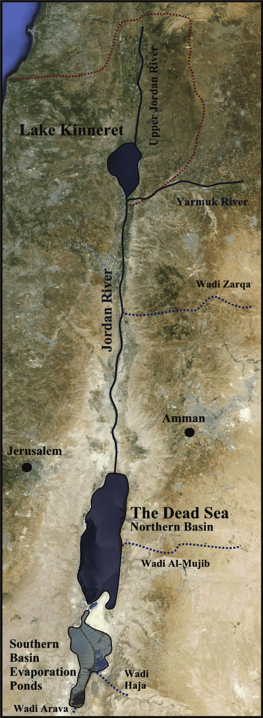

 So, the Dead Sea receives a constant flow of water from the river but because it doesn’t have an outlet all the water can do is evaporate, leaving the salt behind. So, the Dead Sea receives and receives but it doesn’t give; and it is desolate, very empty of life. And because of that, summers can get very hot.  The highest temperature recorded is 124 degrees Fahrenheit.

Today the sermon is going to talk about two options that you have, to be a Giver, or to be a Taker.  The Bible verse for today are the words of Jesus in Matthew 5:48 - “Therefore you shall be perfect, just as your Father in heaven is perfect.”  You can have God as your example and be a giver, or you can use the devil as your example and be a taker.  If you are only a taker you will die like the Dead Sea.  If you only receive and receive, but never give, then your will never experience the abundant life that God wants you to have.  But if you are a person who likes to give, you are going to experience joy and happiness.

So, the lesson for today is for you to be a giver like Jesus. Because if you receive and receive and never give, then you will die like the Dead Sea.