Sample news articles for a conference newsletter (about 200 words each)
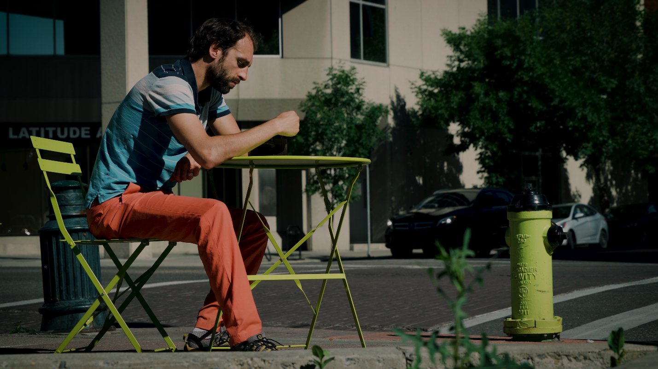
I am a Steward short article #1
Kyle is a water resources engineer from Calgary, Alberta, who designed the flood retaining wall at the world-famous Calgary Stampede grounds. Kyle’s professional experience in protecting the earth adds weight to his conviction that stewardship of the earth is a Christian responsibility. Kyle’s story is one of 24 videos in the I am a Steward video series that have been produced by the North American Division.
I am a Steward aims to increase awareness of the AdventistGiving app and grow viewers’ understanding of stewardship through personal stories. The stories highlight the diverse methods of being a Christian steward. I am a Steward is a creative expression of redemptive grace that reflects every aspect of life: physical, emotional, mental, spiritual, and financial.
The short video testimonies can be seamlessly incorporated into your worship services and ministries. They can be played on/during church announcements, stewardship emphasis days, offering, youth/young adult services, Sabbath School programs, and vespers.
For more information about AdventistGiving, visit AdventistGiving.org. Also, visit https://www.nadstewardship.org/i-am-a-steward-media-kit/ to download the I am a Steward videos and other promotional material you can use in your bulletins, online newsletter, or weekly email updates. These videos will inspire you to be stewards of all the gifts God has given to us.

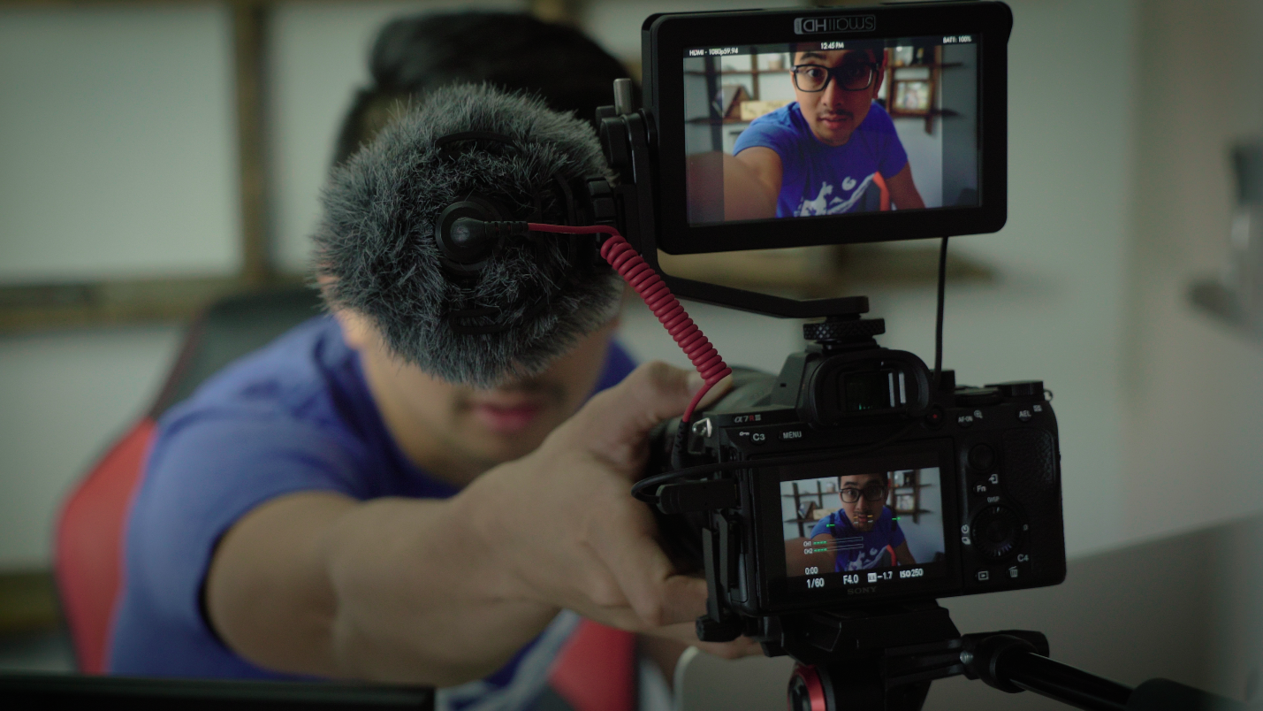
I am a Steward short article #2
Justin Khoe shares his personal faith in God journey from believing there is no God to believing God is real. His belief in God affects every area of his life. Justin believes God gave him his life. Justin is now a steward of his life, living in ways that he believes God has instructed. Justin’s story is one of 24 videos in the I am a Steward video series that have been produced by the North American Division.
I am a Steward aims to increase awareness of the AdventistGiving app and grow viewers’ understanding of stewardship through personal stories. The stories highlight the diverse methods of being a Christian steward. I am a Steward is a creative expression of redemptive grace that reflects every aspect of life: physical, emotional, mentally, spiritual, and financial.
The short video testimonies can be seamlessly incorporated into your worship services and ministries. They can be played on/during church announcements, stewardship emphasis days, offering, youth/young adult services, Sabbath School programs, and vespers.
For more information about AdventistGiving, visit AdventistGiving.org. Also, visit https://www.nadstewardship.org/i-am-a-steward-media-kit/ to download the I am a Steward videos and other promotional material you can use in your bulletins, online newsletter, or weekly email updates. These videos will inspire you to be stewards of all the gifts God has given to us.

