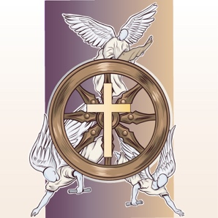
Stewardship: Motives of the Heart
Discussion Questions – The Role of Stewardship
Draw a wheel and label the 5 component parts.
List the 5 main components of a chariot or wagon wheel and the role they play in the wheel’s function.

What similarities can you draw from the function of the axle and the role of Christ in our lives?

Consider the importance of the hub being “true” and perfectly centered in the wheel. What lesson can this teach us about the importance of having true doctrine at the center of our lives?

“The greatest challenge a steward will encounter is the relationship to and the proper management of the life God as provided.” Do you agree with that statement? Why or why not?

