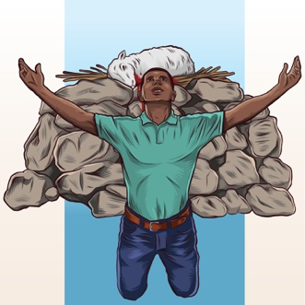
Stewardship: Motives of the Heart
Discussion Questions – Giving Offerings

When was the last time someone gave you a gift spontaneously or over and above what the situation would have called for? How did it make you feel?

When was the last time you gave someone an especially generous or thoughtful gift? How did you feel when you gave it?

Compare the two situations above. Which time did you experience more joy? Why?

Read Acts 20:32-35. What lessons are contained in this verse about hard work and generosity?

Fill in the blank:
“You keep for only what you have by doing good.”
What are two things that happen when we give to the poor and why do they matter?

Someone who cannot see why they should give “extra” to God has probably lost sight of what?

