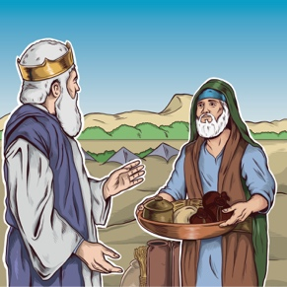
Stewardship: Motives of the Heart
Discussion Questions – The Impact of Tithing

Read Proverbs 6:6. What lessons can we learn from ants about working for the greater good?

Why are we instructed to give our tithe and offerings to the Church? Why do you suppose the command isn’t simply to give 10% to a worthy cause of our choosing?

What five steps are listed that could help reverse the downward trend in tithe and offerings?

Fill in the blank:
“The practice of returning increases that leads to the blessing of .”
Read Malachi 3:10 and Matthew 6:19-21. What do these verses tell us about our spending and our spiritual focus?

What correlation is there between the Tree of Knowledge of Good and Evil and the tithe system?

